HUMAN–COMPUTER INTERACTION (HCI)
UNIVERSITY STUDENT PORTAL MOBILE APPLICATION
Problem Definition and User Research
Group Members:
- Brian Kirunde C027-01-0886/2024
- Alex Njoroge C027-01-0830/2024
- Kibet Kerich C027-01-0917/2024
- Irene Njoroge C027-01-0882/2024
- Irene Serianai C027-01-0848/2024
- Rachael Muriithi C027-01-0895/2024
- Terrence Kamau C027-01-0790/2023
- Joseph Nyori C027-01-0460/2022
- Erickson Kibet C027-01-2798/2024
- Francis Mwariri C027-01-0829/2024

Course: Human–Computer Interaction (HCI)
Project Duration: 3 Weeks
Design Tool: Balsamiq
Platform: Mobile Application

1. Problem Definition
1.1 Background
University students need to access different services during their studies. These services include course registration, fee statements, academic results, and student profile information.
Sometimes, finding these services can be difficult or take too much time. Students may need to use different systems or go through several steps before they find the information they need.
A simple mobile application can bring these important services together in one place.
1.2 Problem Statement
University students may have difficulty accessing important university services quickly and easily. Finding information about fees, results, courses, and student profiles can be confusing and time-consuming.
Therefore, there is a need for a simple University Student Portal Mobile App that allows students to access important university services from their smartphones in one place.
1.3 Target Users
The main users of the application are:
- University students
- New students
- Continuing students
- Students registering for courses
- Students checking fees and academic results
1.4 Main Problems
The main problems we want to solve are:
- Students find it difficult to find university services.
- Students spend too much time looking for information.
- Navigation between services can be confusing.
- Students need quick access to fee information.
- Students need quick access to academic results.
- Students need an easy way to manage their student profile.
1.5 Project Goal
The goal of the project is to design a simple mobile application that brings common university student services together in one place.
The application will allow students to:
- Register for courses
- View fee statements
- View academic results
- Manage their student profile
- Move easily between different services

2. User Research
2.1 Research Objective
The purpose of the user research was to understand students' experiences with university services.
The research focused on:
- How students currently access university services.
- Problems students experience.
- Services students use most.
- Features students need.
- What students expect from a mobile application.
- What would make the application easy to use.
2.2 Research Method
We used short interviews to collect information from potential users.
Number of participants: 5 students
Research method: Student interviews
Interview duration: 10–15 minutes
Location: University campus / online
Target users: University students

3. User Research Questions
The following questions were asked during the interviews:
- How do you currently access university services?
- What problems do you experience when accessing these services?
- Which university service do you use most often?
- How easy is it to find the information you need?
- Would you prefer to access university services through a mobile app?
- Which features would you like to have in the mobile app?
- What would make the app easy to use?
- What problems have you experienced with university systems?
- Would notifications be useful to you?
- What is one thing you would improve about the current system?

4. Research Results
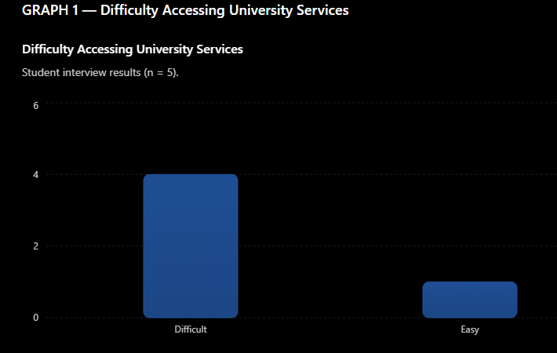
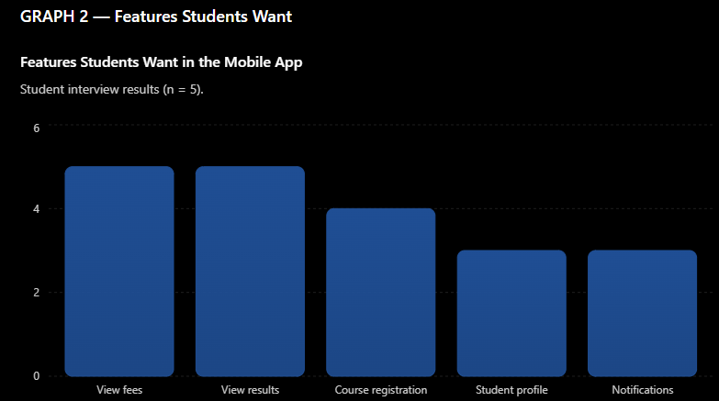
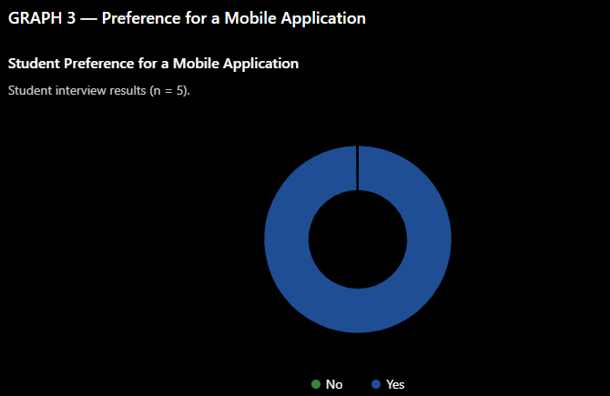
Finding
The most requested features were:
- View fees
- View academic results
- Course registration
- Student profile
- Notifications
Therefore, these features should be given high priority in the mobile app design.

6. Preference for a Mobile Application
Students were asked whether they would like to use a mobile application to access university services.
Response | Number of Students
Yes | 5
No | 0
Total | 5
Graph 3: Preference for Mobile App
Yes: █████████████████████████ 5 students
No: 0 students
Finding
All 5 students said they would like to use a mobile application for accessing university services.
This shows that a mobile student portal could be useful to the target users.

7. Key User Research Findings
The research produced the following main findings:
- 4 out of 5 students found accessing university services difficult.
- 5 out of 5 students wanted to view their fees using the app.
- 5 out of 5 students wanted to view academic results.
- 4 out of 5 students wanted course registration.
- 3 out of 5 students wanted a student profile feature.
- 3 out of 5 students wanted notifications.
- Students preferred having several university services in one application.
- Students wanted simple and clear navigation.
- Students wanted important information to be easy to find.

8. User Needs
Based on the research, students need:
User Need | Importance
Easy access to fees | High
Easy access to results | High
Simple course registration | High
Easy navigation | High
Student profile management | Medium
Notifications | Medium
Clear confirmation messages | Medium

9. Design Implications
The research findings will guide the design of the Balsamiq prototype.
The mobile application should include:
- A simple home/dashboard screen.
- Clear navigation.
- Course registration.
- Fee statements.
- Academic results.
- Student profile.
- Notifications.
- Confirmation messages.
- Easy-to-read information.
- Large, touch-friendly buttons.
- Simple and consistent screen layouts.

10. Conclusion
The user research shows that students need a simple and convenient way to access university services using their smartphones.
The main problems identified were difficulty finding information, confusing navigation, and the time needed to access important services.
The proposed University Student Portal Mobile Application will bring important services together in one place.
The application will focus on simple navigation, easy access to information, and a clear mobile user experience.
The research findings will be used to create the user personas, requirements, task flows, and Balsamiq wireframes for the next stage of the project.

Appendix A: Participant Summary
Participant | User Type | Interview Completed
P01 | University Student | Yes
P02 | University Student | Yes
P03 | University Student | Yes
P04 | University Student | Yes
P05 | University Student | Yes
Note: The results in this document are example results based on five participants. The group should replace them with the actual results collected during the interviews before final submission.

